DocuTracks Version 2.0
Installation SSL Certificate Guide
Mozilla Firefox 1.5

Docutracks Installation Steps

Step 1

Enter the web URL http://mylogin.docutracks.com in the browser [Mozilla Firefox 1.5]

The SSL Certificate message appears as shown below.

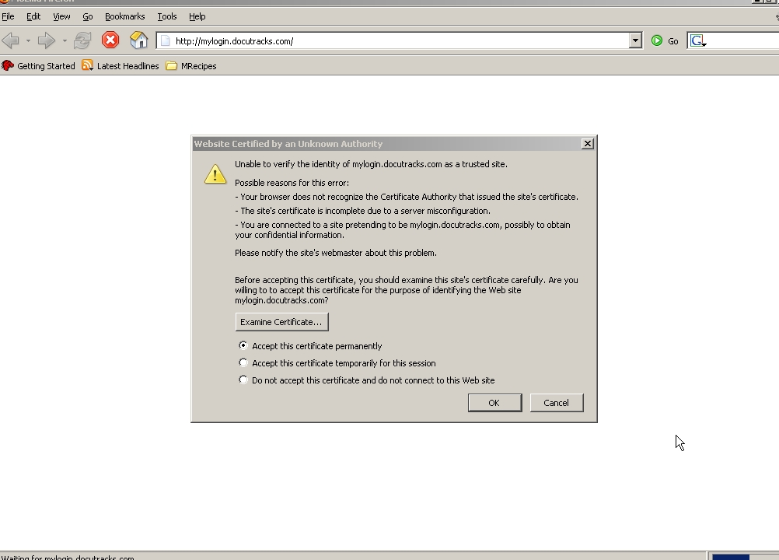

To accept the SSL certificate permanently do the following:

- Select the Option “Accept this certificate permanently
- Click OK button.
- The Docutracks Login screen appears.

Note: This SSL Certificate will appear only for the initial Docutracks installation procedure.

To avoid this message do the following:

- Go to the Tools menu -> Options.
- Click on the Advanced Options and then select the Security Tab

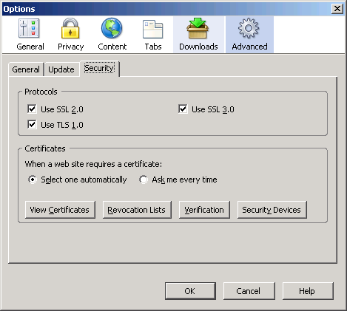

- Select / Enable the Use SSL 2.0 and Use SSL 3.0 check boxes in the Protocols frame.
- Below the When a web site requires a certificate heading, select the “Select one automatically” option.
- Click on the “View Certificates” button.
- The Certificate manager window will open as shown below.

Step 2

- In the Certificate manager window click on the Web Sites tab.

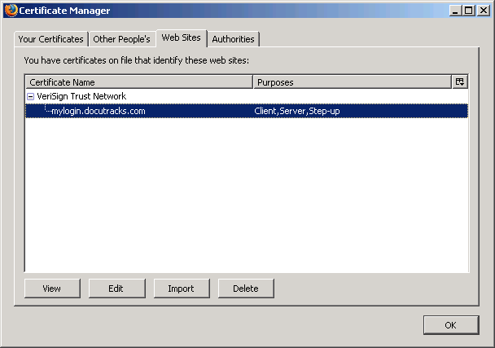

- You can view the installed certificate.
- You can also get the details of the installed certificate by double clicking on the SSL symbol.
- Click OK button.
- The DocuTracks Login screen appears.

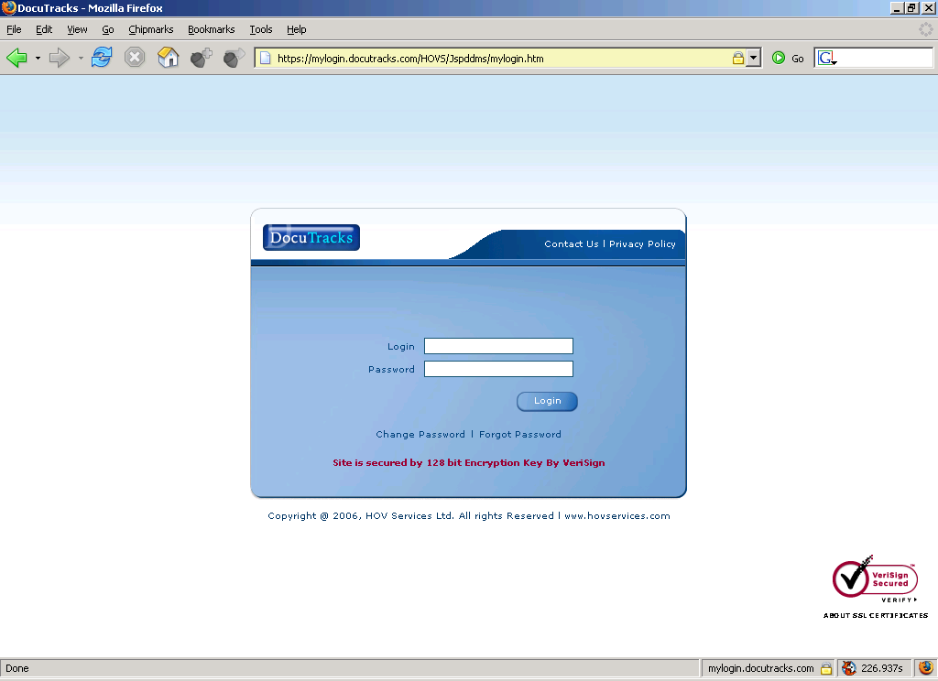
SSL symbol

