DocuTracks
User’s Maual
Version 2.0

© 2006 HOV Services, LTD
All rights reserved. This product and related documentation are protected by copyright and distributed under licensing restricting their use, copying, distribution, and recompilation. No part of this product or related documentation may be reproduced in any form or by any means without prior written authorization of HOV Services, LLC.
While every precaution has been taken in the preparation of this book, HOV Services, LLC assumes no responsibility for errors or omissions. This publication and features described herein are subject to change without notice.

RESTRICTED RIGHTS LEGEND:

Use, duplication, or disclosure by the government is subject to restrictions as set forth in subparagraph (c)(1)(ii) of the Rights in Technical Data and Computer Software clause at DFARS
252.227-7013 and FAR 52.227-19.

TRADEMARKS:

HOV Services, LLC, the HOV Services, LLC logo, DocuTracks Log are trademarks or registered trademarks of HOV Services, LLC.
All other product names mentioned herein are trademarks or registered trademarks of their respective owners.

HOV Services, LLC
U.S. Headquarters:

50 Airport Parkway
San Jose, CA 070111
Tel: (732) 208-8221
Fax: (908) 754-5278
e-mail: info@docutracks.com
http://www.docutracks.com

Please direct all comments regarding this publication to review@docutracks.com

Contents
Preface 8
About this Guide 8
What this guide covers 8
Notational conventions 8
Customer Support 9
Chapter 1 Introduction 10
Introduction 10
System Requirement 10
Features 10
Chapter 2 Getting Started 11
Logging In To DocuTracks Application 11
To Log In 11
Logging Out Of DocuTracks Application 13
To Log Out 13
Changing Password 14
To Change Your Account Password 14
Forgot Password 15
To Obtain Forgotten Password 15
Contact Us 16
To View the Contact Details 16
Privacy Policy 17
To View the Privacy Policy Details 17
Home Page 18
Resource Link 19
To send the Feedback 20
Main Menu 22
Chapter 3 Project View 24
Overview 24
To create New Folder 26
To create New Folder by Shortcut menu 26
To Rename folder 28
To Rename a Folder by Shortcut menu 29
To Delete folder 30
To Delete folder by Shortcut menu 30
To Download folder 30
To Download folder by Shortcut menu 30
To Search folder 31
To Search folder by Shortcut menu 32
Shortcut Menu 32
Folder Level Shortcut menu 32
File Level Shortcut menu 33
Document Profile 41
Properties 42
Workspace Menu 43
Upload Tab 44
Chapter 4 Template Profile 47
Global Template 47
Local Template 47
To create New Profile 48
To create New Profile by Shortcut Menu 49
To Rename Profile 49
To Delete Profile 50
To create New Folder 50
To create New Folder by Shortcut menu 51
To Rename Folder 52
To Rename Folder by Shortcut menu 53
To Delete Folder 53
To Delete Folder by Shortcut menu 53
Chapter 5 User Profile 55
User Info 55
Personal Info Tab 57
Regional Info Tab 58
Team Members Tab 59
Chapter 6 Permission 60
Root Folder Permissions 60
Project Permissions 61
Files permissions 62
By Project 64
By User 65
By Template 66
Chapter 7 Administration 68
Users 68
Groups 71
Search 73
Chapter 8 Reports 74
Uploaded Files 75
User Logs 77
Deleted Files 78
User Audit 79
Retention Files 80

Table of Figures

Figure 1. Login 12
Figure 2. Home screen 13
Figure 3. Changing Password 14
Figure 4. Forgot Password 15
Figure 5. Contact Us 16
Figure 6. Privacy Policy 17
Figure 7. DocuTracks Home Page 18
Figure 8. About Page 19
Figure 9. Feedback Form 20
Figure 10. Project View Tab 24
Figure 11. Select All 25
Figure 12. Resize Columns 25
Figure 13. Create a New Folder 26
Figure 14. Shortcut menu 27
Figure 15. Create A New Folder 28
Figure 16. Rename screen 29
Figure 17. Search screen 31
Figure 18. Folder Level Shortcut menu 32
Figure 19. File Level Shortcut menu 33
Figure 20. Alert and Notification 35
Figure 21. Email 40
Figure 22. Document Properties 41
Figure 23. Properties 42
Figure 24. Project View Tab – Select Folder 44
Figure 25. Upload Tab 45
Figure 26. Choose File 45
Figure 27. Browse File 46
Figure 28. Attached File 46
Figure 29. Template Profile 47
Figure 30. Create A New Profile 48
Figure 31. Template Profile 48
Figure 32. Rename 49
Figure 33. Create a New Folder 50
Figure 34. Create A New Folder 51
Figure 35. Rename 52
Figure 36. User Info Tab 55
Figure 37. Personal Info 57
Figure 38. Regional Info 59
Figure 39. Root Folder Permissions 60
Figure 40. Folder Permissions 61
Figure 41. File Permissions 63
Figure 42. Permission By Template 66
Figure 43. User 68
Figure 44. Retention Files Report 80

Preface
The topics covered in this chapter are:
- About this Guide
- Summary of Contents
- Typographic Notation
- Customer Support

About this Guide
This User’s Guide facilitates the effective use of the DocuTracks software. It familiarizes end-users with the DocuTracks Application and provides detailed instructions on how to perform their tasks using the software.
The User’s Guide on DocuTracks Application is developed in user-friendly manner.

What this guide covers
The following topics are included in this guide:
- Introduction
- Getting Started
- Project View
- User Profile
- Reports

Notational conventions
The following notational conventions are used to distinguish elements of text throughout this guide:
Bold | Bold text indicates selectable window buttons and screen names.
Monospace | Monospace text indicates the contents of files, queries, or the output from commands.
MonospaceItalic | Italicized monospace text indicates context-specific values, such as path names and file names.
Blue type | Used for hyperlinks in this guide

Customer Support
Address | HOV Services,  50 Airport Parkway  San Jose, CA 90000
Telephone Number
Fax Number
Email Address | info@docutracks.com
Corporate Website | http://www.hovservices.com
- Introduction

Introduction
DocuTracks is a document management and workspace sharing application. DocuTracks secure workspace feature flexible document libraries and discussion forums. Brand your workspace with your logo and colors. Customize by selecting the features you need, labeled in your own terminology.
A DocuTracks account gives you unlimited workspaces. Create templates so teams or departments can be launched in minutes. Manage users across the organization. All for a low pay-as-you-go subscription fee.

System Requirement

Software Requirement
To effectively use DocuTracks, the minimum browser requirement is
- Internet Explorer 6.0 or higher, Mozilla FireFox, and
- Internet access

Hardware Requirement
- No Hardware Requirement
- Additional Storage space is optional.

Features
- DocuTracks provides simple, browser-based access.
- DocuTracks offers a secure way for companies to collaborate and share documents and team information with those key individuals outside your organization.
- A DocuTracks account gives you unlimited workspaces to upload and download the files.
- Facilitates to create templates so teams or departments can be launched in minutes and manage users across the organization.
- DocuTracks multi-file upload and download and the multi-file upload features save additional time.
- Getting Started
This chapter provides information you will need to know about getting started with the DocuTracks Application. It also provides information on changing user password.
This chapter includes following sections:
- Logging in to the DocuTracks Application
- Logging out of the DocuTracks Application
- Changing Password
- Forgot Password

Logging In To DocuTracks Application
All individuals need a username and password to log in to the Application.
Your DocuTracks administrator is responsible for providing you with a URL (server address), a username, and a password. If you do not have this information yet, contact your administrator.

To Log In
- Open your web browser.
- Enter the URL provided by your administrator. The URL looks something like this:
http://mylogin.docutracks.com or https://mylogin.docutracks.com
- Press ENTER
Result: The Login screen appears.
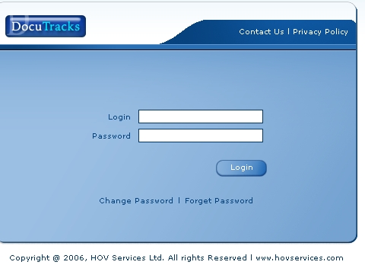
- Login
- Enter your user name in the Login Name text box.
- Enter your password in the Password text box.
The user name and the password are case sensitive.
- Click Login, or press ENTER.
Result: The Home Page appears.
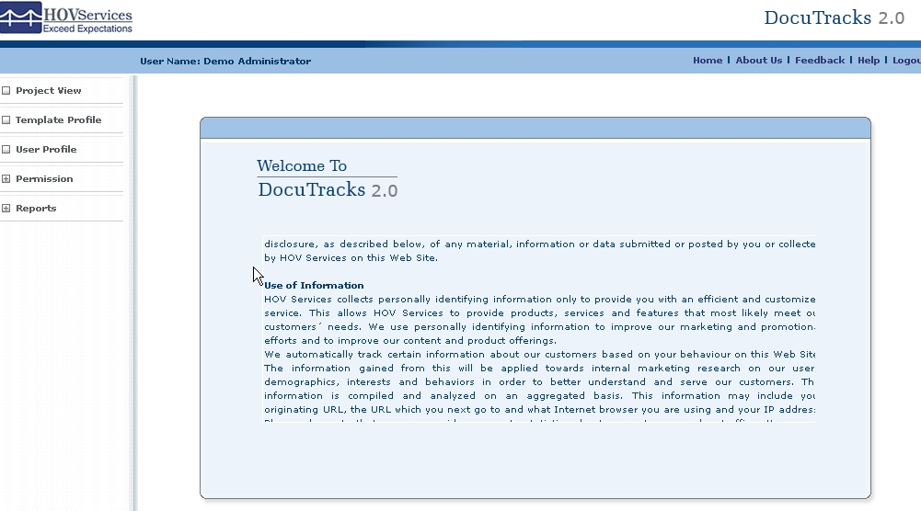
- Home screen

Logging Out Of DocuTracks Application
You need to log out of the Application when you finish your working with the Application.

To Log Out
To log out of the Application:
- Click Logout on the Home Page.
Result: The Login Page appears.
The Logout option is available on all the screens.
Please log out of the application before closing the browser or using it to view another site.
The application provides auto logout after 30 minutes of idle time.

Changing Password
Using the Change Password option, you can change the password for your account.
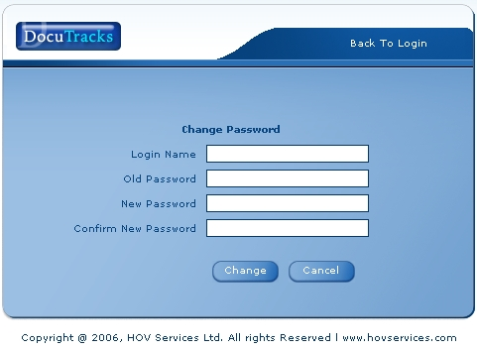
- Changing Password

To Change Your Account Password
You can change the password for your account using the Change Password option.
- Enter your user name in the Login name text box on the DocuTracks Login Page.
If the Login Name is not provided then an error message appears “Enter Login Name to change Password”
- Click Change Password for changing the password.
Result: The Change Password window appears.
- Enter your present password in the Old Password text box.
- Enter your new password in the New Password text box.
- Re-enter your new password in the Confirm New Password text box to confirm the new password.
- Click Change. A message “ Password Has Been Changed Successfully!” appears.
- Click OK button.
Button Options Available:
Cancel: Will close the Change Password screen.

Forgot Password
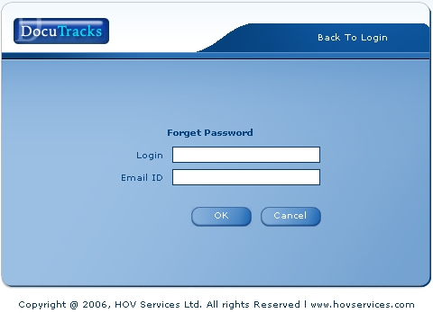
- Forgot Password

To Obtain Forgotten Password
To obtain the forgotten password please follow below steps:
- Enter your User ID in the User ID text box
- Enter e-mail address in the Email Address text box
- Click Submit button
Result: A password will be e-mailed to you

Contact Us
Contact Us provides the contact details of the HOV Services.

To View the Contact Details
- Click on the Contact Us link.
Result: The Contact Us screen appears.
- To return to the login Page click on the Login Page link.
Result: The Login Page appears.

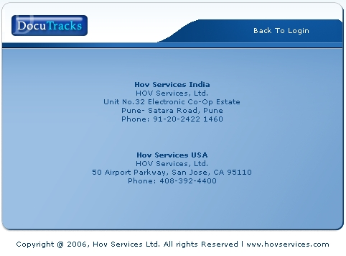
- Contact Us

To view the web site of the HOV Services you can click on the www.hovservices.com

Privacy Policy
Privacy Policy provides all the policies mentioned by the HOV.

To View the Privacy Policy Details
- Click on the Privacy Policy link.
Result: The Privacy Policy screen appears.
- To return to the login Page click on the Back To Login Page.
Result: The Login Page appears.
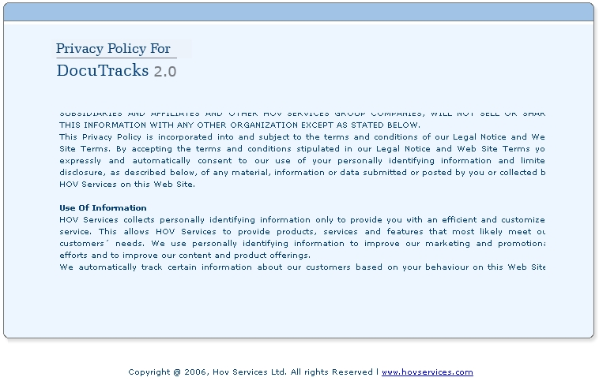
- Privacy Policy
To view the web site of the HOV Services you can click on the www.hovservices.com

Home Page
After the successful login you will be on the Home Page with different options. The Home Page displays the options accessible to you, authorized by the DocuTracks administrator.

The Navigation options may be different for the different user as per his/her predefine rights.
Logged in User Name

Company Logo

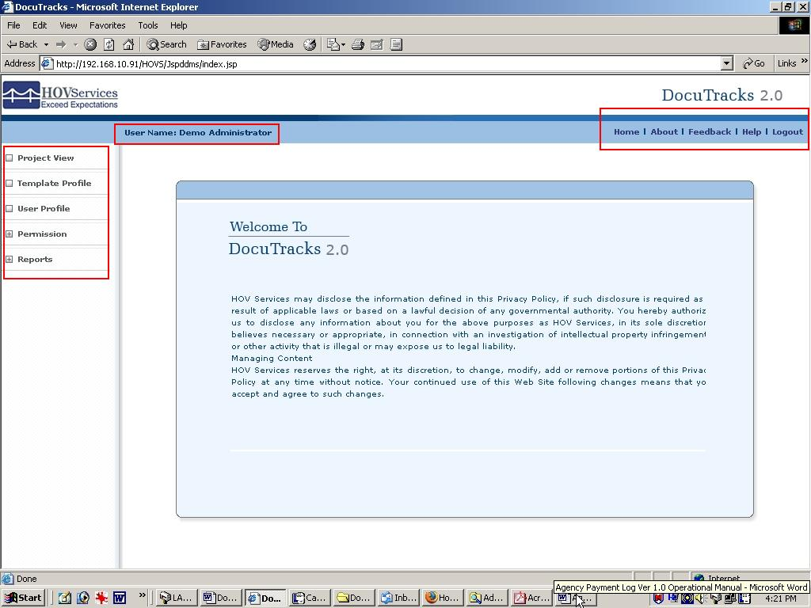
Main Menu

Resource Link

- DocuTracks Home Page

The DocuTracks Home Page displays the main menu items and the resource links. The Home Page can be customized with your company logo.

Resource Link
Resource Link is located at the right side of the Home Page. Each of the option is explained below.

Home
To view Home Page follow the below steps:
- Click Home from the Resource Link.
Result: The Home Page is displayed.

About
To view the Technical Support details follow the below steps:
- Click About from the Resource Link.
Result: The About displays the details about the Technical Support email address and the web URL. It also displays the End User Agreement.
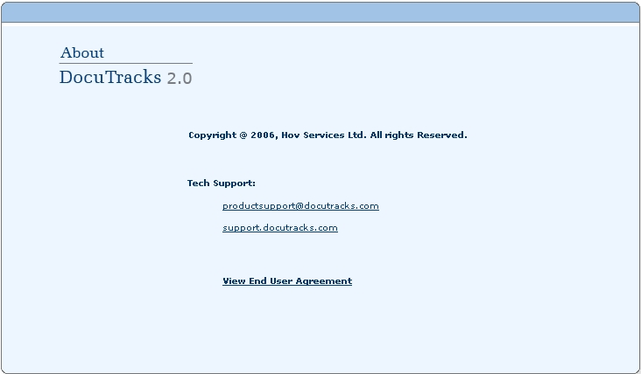
- About Page
To view the End User Agreement follow the below steps:
- Click View End User Agreement link
Result: The End User Agreement appears.

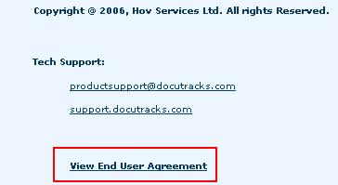

Feedback
We welcome your feedback on the Application.

To send the Feedback
To send the Feedback follow the below steps:
- Click Feedback from the Resource Link.
Result: The Feedback Page appears.
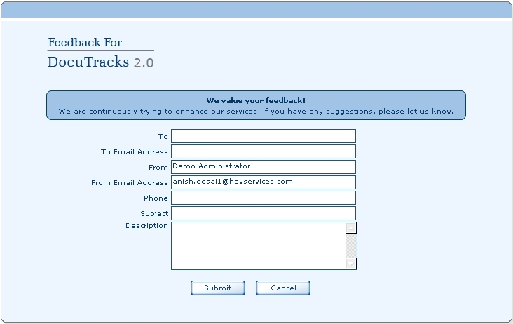
- Feedback Form

- Enter the name of the person you are sending the message in the To field.
An error message pop up box will appear if the To field is not entered and Submit is clicked. Message Reads “Name should not be empty“
- Enter the emails address of the person you are sending the message in the To Email Address field.
An error message pop up box will appear if the To field is not entered and Submit is clicked. Message Reads “Email Id should not be empty“
- Enter the your name in the From field.
- Enter your emails address in the From Email Address field.
- Enter the your phone number in the Phone field.
- Enter the subject in the Subject field.
An error message pop up box will appear if the To field is not entered and Submit is clicked. Message Reads “Subject should not be empty“
- Enter your suggestions in the Description Text Box.
An error message pop up box will appear if the To field is not entered and Submit is clicked. Message Reads “Description should not be empty“
- Click on Submit button

Button Options Available:
Cancel: Will clear the data from Subject and Description fields.

Help
To view the Online Help follow below steps:
- Click Help from the Resource Link.
Result: Displays the On-Line Help for the DocuTracks Application.

Logout
For more information please refer to Logging out Of DocuTracks Application

Main Menu
Horizontal Bar is located at the left side of the Home Page.
Menu accessibility will depend on the permission given to the Users.
Main Menu has following menus:
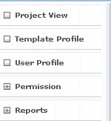

Project View
Project View consists of two Tabs as follows:
- Project View Tab
- Upload Tab

Template Profile
It allows user to create project folders based on selected templates. For Example: Legal Template Profile

User Profile
User Profile consists of four Tabs as follows:
- User Info Tab
- Personal Info Tab
- Regional Info Tab
- Team Members Tab

Permission
Permission option includes three options as follows:
  - By Project
  - By User
  - By Template

Reports
Reports option includes two options
  - Upload Files
  - User Logs
  - Deleted Files
  - User Audit
  - Retention Files
Each of the menus mentioned above is discussed in detail below.

- Project View

Overview
Project View is the default tab selected. There are three tabs are viewed namely
- Project View: Allows you to create, rename, delete, download and search folders or files
- Upload: Allows you upload the file to the particular folder.

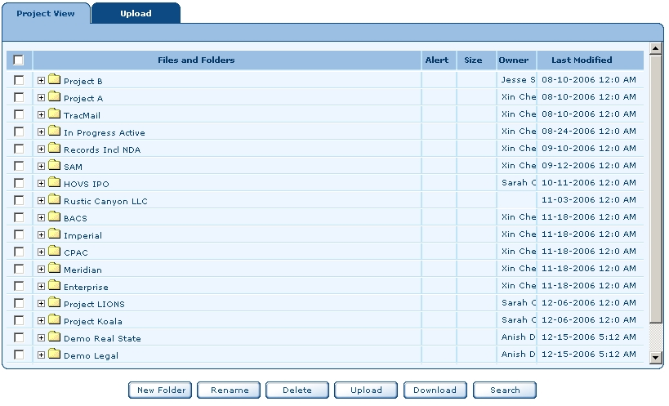
- Project View Tab

Select All
You can select all the folders by clicking on the top check box.
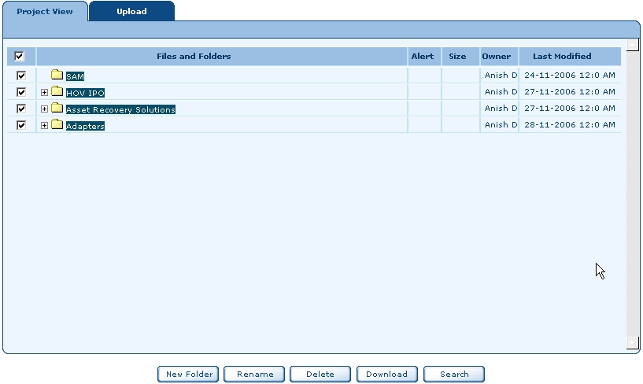
- Select All
Resizing Columns
You can resize the Alert, Size, Owner, and Last Modified columns.
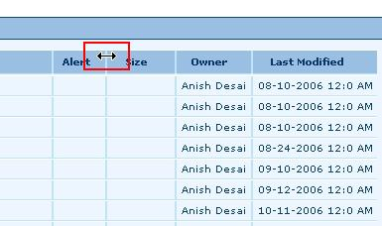
- Resize Columns
To resize the Columns follow below steps:
- Keep the mouse on the blue line
Result: The Double arrow appears.
- Hold and drag the mouse to resize the column.
The columns can also overlap each other.
The Project View allows you to do the following:
- Create new folders
- Rename existing folders
- Delete the folders
- Download
- Search
Each of the above options are explained below.

To create New Folder
- Click on the New Folder button.
Result: Create A New Folder screen appears.
- Enter the name of the folder in the New Folder Name field.
Message Reads: “Please enter Name.”
An error message pop up box will appear if the New Folder Name field is not entered and Ok is clicked.
- Enter the description in the Description field.
- Select the Use Template check box incase you wish to use the Template.
- Click OK button
Message Reads: “Are you sure? Do you want to create a new folder?”
- Click OK button
Message Reads “ <Folder name> created successfully”.
Button Options Available:
Cancel: Will close the New Folder Name screen and the new folder is not created.

To create New Folder by Shortcut menu
- To create a folder right click anywhere in the work area
Result: A shortcut menu bar appears
- Click New Folder option
Result: Create A New Folder screen appears.
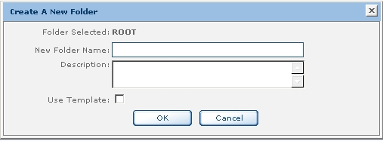
- Create a New Folder
- The name of the selected folder appears by default. For Example in the above screen it is ROOT.
- Enter the new folder name in the New Folder Name text box
An error message pop up box will appear if the New Folder Name field is not entered and Ok is clicked. Message Reads: “Please enter Name.”
- Enter the description in the Description text box.
- Select the Use Template check box if you wish to use template.
Result: A template combo box appears. Select the template you wish. For more information please refer to Template Profile.
- Click OK button
Message Reads: “Are you sure? Do you want to create a new folder?”
- Click OK button
Message Reads “ <Folder name> created successfully.
Button Options Available:
Cancel: Will close the New Folder Name screen and the new folder is not created.

To create a sub folder
To create a sub folder
- Select the any folder
- Right click the folder
Result: A shortcut menu appears.
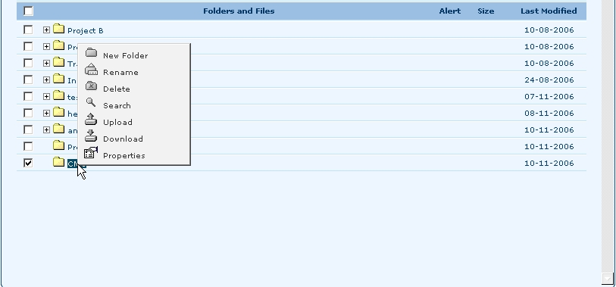
- Shortcut menu
- Select New Folder option.
Result: The Create A New Folder screen appears.
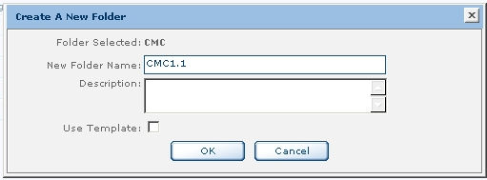
- Create A New Folder
- Enter the new folder name in the New Folder Name text box. For Example in the above screen it is CMC1.1
An error message pop up box will appear if the New Folder Name field is not entered and Ok is clicked.
Message Reads: “Please enter Name.”
- Enter the description in the Description text box.
- Select the Use Template check box if you wish to use template.
Result: A template combo box appears. Select the template you wish.
- Click OK button
Message Reads: “Are you sure? Do you want to create a new folder?”
- Click OK button
Message Reads: “ <Folder name> created successfully”.
Button Options Available:
Cancel: Will close the New Folder Name screen and the new folder is not created.
To view the newly created folders double click on the main folder.

To Rename folder
To rename the folder follow the below steps:
- Select any folder
Result: A check mark appears.
- Click Rename button
Result: The Rename screen appears.

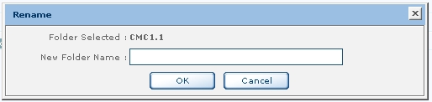
- Rename screen
- Enter the new name in the New Folder Name text box
- Click Ok button
Message Reads: “Are you sure? Do you want to rename a folder?”
- Click Ok button
Message Reads: “Folder renamed successfully”
- You cannot rename the new folder with the same name.
Message Reads: “Old and New name are same. Please Enter Different Name.”
- Click Ok button and enter the new name.

Button Options Available:
Cancel: Will close the Rename screen.

To Rename a Folder by Shortcut menu
To rename the folder follow the below steps:
- Select any folder
Result: A check mark appears.
- Right click the folder
Result: A Shortcut menu appears.
- Click Rename button
Result: The Rename screen appears.
- Enter the new name in the New Folder Name text box
An error message pop up box will appear if the New Folder Name field is not entered and Ok is clicked. Message Reads: “Please enter Name.”
- Click OK button
Message Reads “Are you Sure, Do you want to Rename Folder?’
- Click OK button
Button Options Available:
Cancel: Will close the Rename screen.

To Delete folder
To delete the folder follow the below steps:
- Select any folder
- Click the Delete button
Message Reads: “Are you sure? Do you want to delete?”
- Click OK button
Message Reads: “<Folder name> deleted successfully”
- Click OK button

To Delete folder by Shortcut menu
To delete the folder follow the below steps:
- Select any folder
- Right click the folder
- Click Delete button
Message Reads: “Are you sure? Do you want to delete?”
- Click OK button
Message Reads: “<Folder Name> deleted successfully”
- Click OK button

To Download folder
To download the folder follow the below steps:
- Select any folder
- Click the Download button
Message Reads: “Are you Sure, Do you want to download?”
- Click OK button
- Click Save to save the .zip file on your local drive.
Button Options Available:
Cancel: Will close the Rename screen.

To Download folder by Shortcut menu
To download the folder follow the below steps:
- Select the folder
- Right click the folder
- Click on the Download button
Message Reads: “Are you Sure, Do you want to download?”
- Click OK button
- Click Save to save the .zip file on your local drive.
Button Options Available:
Open: Will open the file using WinZip utility
Save: Will save the .zip file on the selected path.
Cancel: Will close the Rename screen.
More Info: Will display the help.

To Search folder
To search a folder follow the below steps:
- Click Search button
Result: Search screen appears.
- Below the Search for Files or Folders, enter the name of the file or folder.
- Below the Search in select the folder where you wish to search
- If you wish to search for specific text then enter in the Containing text.
- Click the ‘X’ sign
Result: Will close the Search screen.

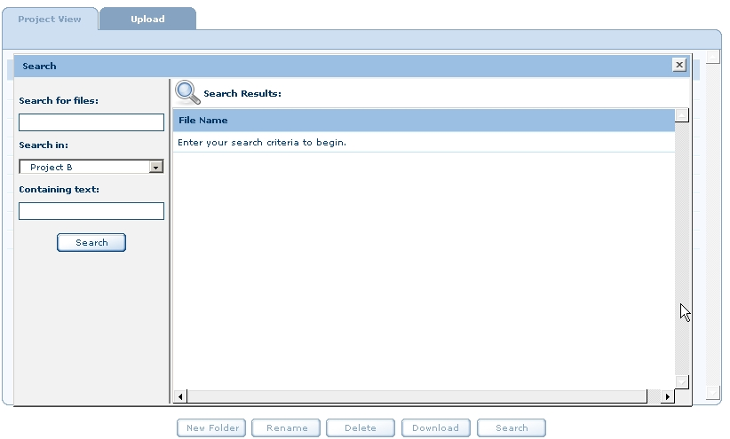
- Search screen

To Search folder by Shortcut menu
To search a folder follow the below steps:
- Click the Project View Tab
- Right any folder
- Select Search option
Result: Search screen appears.
- Below the Search for Files or Folders, enter the name of the file or folder.
- Below the Search in select the folder where you wish to search
- If you wish to search for specific text then enter in the Containing text.

Shortcut Menu
There are three Shortcut menus available in the Project View Tab.
- Folder Level Shortcut menu
- File Level Shortcut menu
- Workspace Level Shortcut menu

Folder Level Shortcut menu
To view the Folder level Shortcut menu follow the below steps:
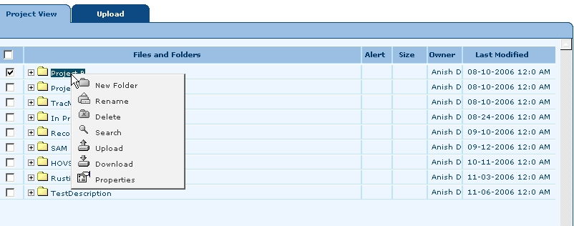
- Folder Level Shortcut menu
- Select the particular folder
- Right click the selected folder
Result: A Folder Level Shortcut menu appears.
The options are explained as below:

Shortcut Menu option | Description
New Folder | Creates a new folder under the selected folder
Rename | Renames the selected folder.
Delete | Deletes the selected folder.
Search | Searches the selected folder.
Upload | Opens the Upload tab and allows you to upload the file in the selected folder.  You have to select the folder in the Project View Tab
Download | Downloads the selected folder.
Properties | Displays the properties of file.  You can modify the details from the Description field.

File Level Shortcut menu
To view the File Level Shortcut menu follow the below steps:
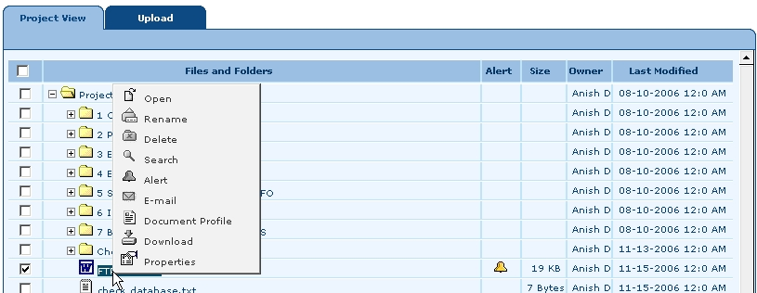
- File Level Shortcut menu
- Select the particular folder
- Collapse the folder
- Select any particular file
- Right click the file
Result: A File Level Shortcut menu appears.
The options are explained as below:
Shortcut Menu option | Description
Open | Opens the selected file.
Rename | Renames the selected file.
Delete | Deletes the selected file.
Search | Searches the selected file.
Alert | Sets an Alert for a selected file. For details please see the information below.
Email | Sends an email to the particular person. For details please see the information below.
Document Profile | For details please see the information below.
Download | Downloads the selected folder.
Properties | Displays the properties of file.  You can modify the details from the Description field.

Alert
To set an Alert please follow the below steps:
- Click the folder
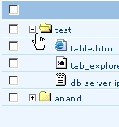

- Select the file and right click
Result: The Shortcut menu appears.
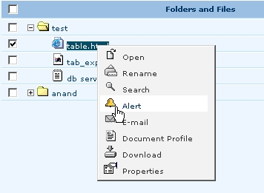
- From the Shortcut menu select Alert
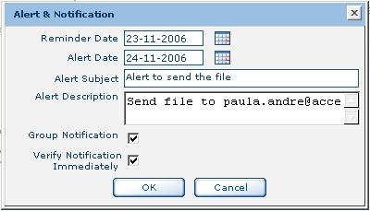
- Alert and Notification
- Click on the calendar icon and select the Reminder Date.
Result: An Email notification will be send to the User or to all the team members.
An error message appears if you don’t enter the Reminder Date and click OK “Enter reminder Date”
- Click on calendar icon and select the Alert Date
Result: Result: An Email notification will be send to the User or to all the team members.
An error message appears if you don’t enter the Alert Date and click OK “Enter Alert Date”
If the Reminder Date is greater than Alert Date then a message appears “Alert Date Should Be Greater Than Reminder Date.”
- Enter the subject in the Alert Subject
An error message appears if you don’t enter the Alert Subject and click OK “Enter Alert Subject”
- Enter the description in the Alert Description
An error message appears if you don’t enter the Alert Description and click OK “Enter Alert Description”
- Select the Group Notification check.
Result: An Email notification will be send to the group users who have rights to the particular file.
- Select the Verify Notification Immediately check box if you wish to send the verify notification
Result: An Email notification will be send to the User.
- Click OK
Result: The Alert is saved for that file.
Button Options Available
Cancel: Will close the Alert and Notification screen.
To add multiple Alerts repeat from Step 2.

To view Alerts (Owner)
To view Alerts follow the below steps:
- Take the cursor near to the Alert
Result: A tool tip will be displayed “Click here to view Alerts”
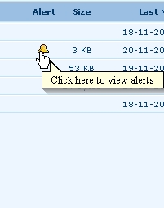
- Click the Alert
- Result: A list of alerts appears.
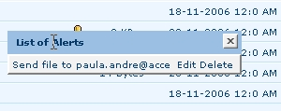
- Click on the Alert
Result: The Alert and Notification screen appears.

To view Alerts (Users)
To view Alerts follow the below steps:
- Take the cursor near to the Alert
Result: A tool tip will be displayed “Click here to view Alerts”
- Click the Alert
Result: A list of alerts appears.
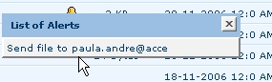
- Click on the Alert
Result: Alert and Notification screen appears.
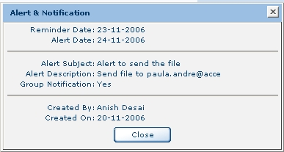

- Click Close button

To Edit Alerts (Owner)
To edit the Alerts follow the below steps:
Only the user (owner) who created the Alert can edit the Alert.
- Take the cursor near to the Alert
Result: A tool tip will be displayed “Click here to view Alerts”
- Click the Alert
Result: A list of alerts appears.
- Click on Edit link
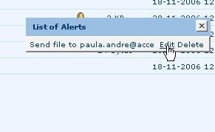
Result: The Alert and Notification screen appears.
- Modify the fields you wish.
- Click OK button
Result: The changes are saved.

To Delete Alerts (Owner)
To edit the Alerts follow the below steps:
Only the user (owner) who created the Alert can edit the Alert.
- Take the cursor near to the Alert
Result: A tool tip will be displayed “Click here to view Alerts”
- Click the Alert sign
Result: A list of alerts appears.
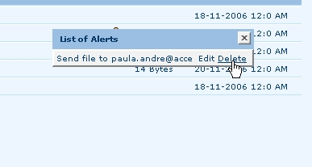
- Click on Delete link
Message Reads: An error message appears “Do you want to delete alert?”
- Click OK button
Result: An alert is deleted.

Email
Email can be send to multiple users.
To send an Email please follow the below steps:
- Select the particular folder
- Select the Email option
Result: The Email screen appears.
- Enter the email address in the To field.
- The email address in the From field is automatically viewed. You cannot modify the address.
- Enter the subject in the Subject field.
- By default, the file selected is attached.
- Enter the text in the text box.
- Click Send to send the email.

Button Options Available
Cancel: Will close the Email screen.

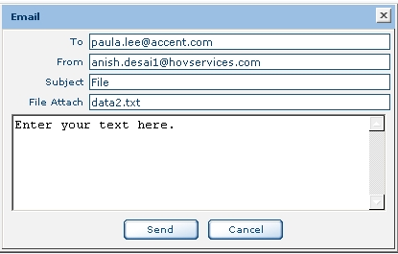
- Email
You can send only one file at a time.

Document Profile
Document Profile displays the file information who created, when was it created, Last modified, Date modified, File extension and size of the bytes.
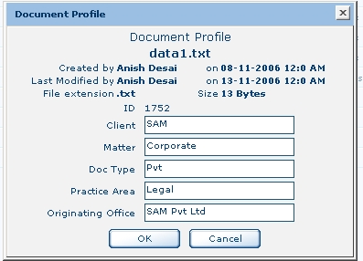
- Document Properties
To view the Document Profile please follow the below steps:
- Select the particular folder
- Select the Document Profile option
Result: The Document Profile screen appears.
- Enter the Client name in the Client field.
- Enter the Matter in the Matter field.
- Enter the Doc Type in the Doc Type field.
- Enter the Practice Area in the Practice Area field.
- Enter the office name in the Originating Office field.
- Click OK button.

Button Options Available
Cancel: Will close the Document Profile screen.

Properties
To view the Properties follow the below steps:
- Select the folder
Result: Properties screen appears
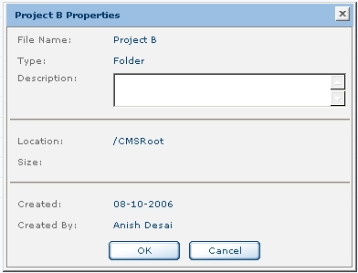
- Properties
- The Properties screen displays the details like File Name, Type, Location, Size, Created Date and Created By. You can enter the information about the selected folder in the Description.
Button Options Available:
OK: Save the information entered in the Description and close the Properties screen.
Cancel: Will close the Properties screen.

Workspace Menu
Workspace menu appears when you click anywhere in the workspace.
To view the workspace menu follow the below steps:
- Right click anywhere in the workspace
Result: The Workspace menu appears.
The options are explained as below:
Workspace Menu | Description
New Folder | Creates a new folder under the selected folder
Search | Searches the selected folder or a file.

Upload Tab
You can upload the existing files or folders in the Upload Tab.
To Upload the file or folder follow the below steps:
- From the Project View Tab select the folder.
If a folder is not selected and you click on Upload Tab a message appears ” Please select at least one folder”. You can select only one folder at a time.
- Project View Tab – Select Folder
You can upload more than one file in the Upload Tab.
- Click the Upload Tab
Result: The Upload Tab appears.

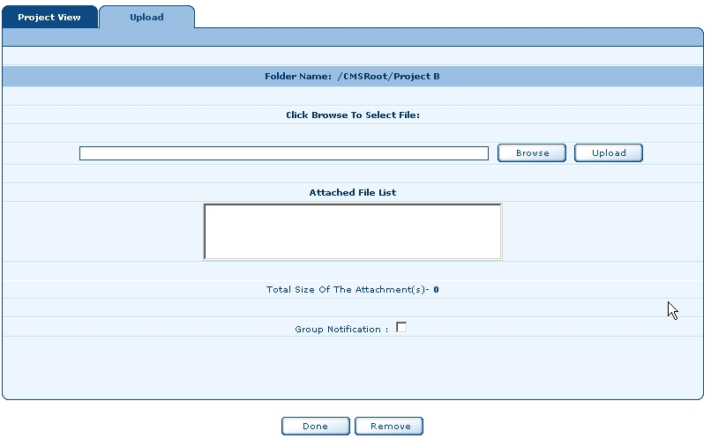
- Upload Tab
- Click Browse button
Result: The Choose File screen appears.
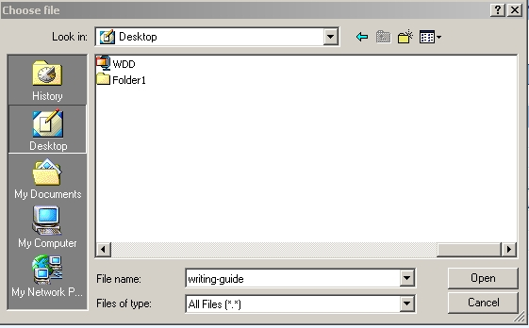
- Choose File
- Select the file you wish
- Click Open button
Result: The selected file is displayed in the Upload Tab
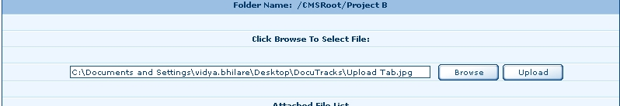
- Browse File

- Click Upload button
Result: The file is uploaded and displayed in the Attached File List as shown below.
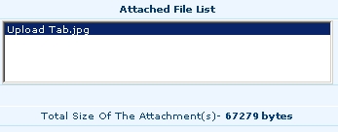
- Attached File
- Click Group Notification
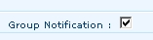
Result: An email is send to the group notifying that the particular file is uploaded.
- Click Done button
Result:
1. Message Reads: “File uploaded”. The total size of the attachment(s) is displayed.
2. If there is error while uploading then a message appears ” File cannot be uploaded”
3. The file is uploaded in the selected folder from Project View Tab.
Button Options Available:
Remove: Will remove the attached file from the Attached File List.

- Template Profile
Template Profile helps you to create a template for a company. You can create two types of templates namely:
- Local Template
- Global Template
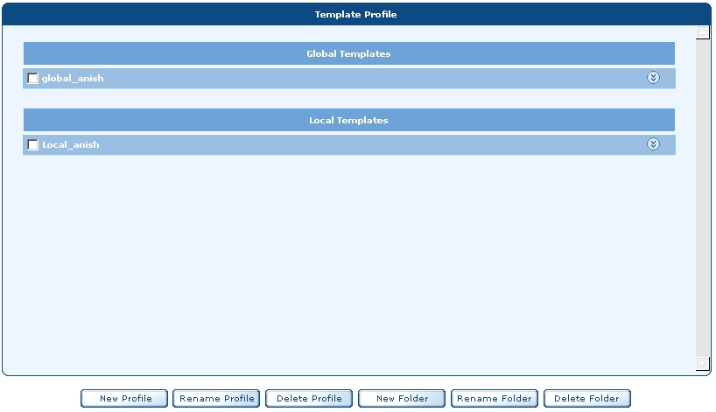
- Template Profile

Global Template
Global Template is accessible to anyone who has permission to access the folder or file.

Local Template
Local Template is not accessible to anyone except to the user who created the template.

To create New Profile
To create New Profile follow the below steps:
- Click on the Template Profile
Result: The Template Profile Tab appears.
- Click New Profile button
Result: Create A New Profile screen appears.
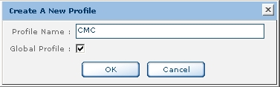
- Create A New Profile
- Enter the profile name in the Profile Name field. For Example in the above screen it is Profile1.
- Select Global Profile check box if you wish to make the Template Global.
If the Global Profile is not checked then the Template is Local Template
- Click OK button
Message Reads “Are you Sure, Do you want to create new profile?”
- Click OK button
Message Reads “ <Folder name>created successfully”. For Example in the screen below it is CMC.

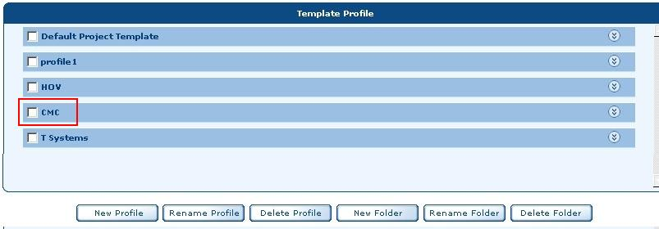
- Template Profile

To create New Profile by Shortcut Menu
To create New Profile follow the below steps:
- From the Vertical Bar click the Template Profile
Result: The Template Profile Tab appears.
- Right click anywhere in the Workspace.
Result: New Profile Shortcut menu appears.

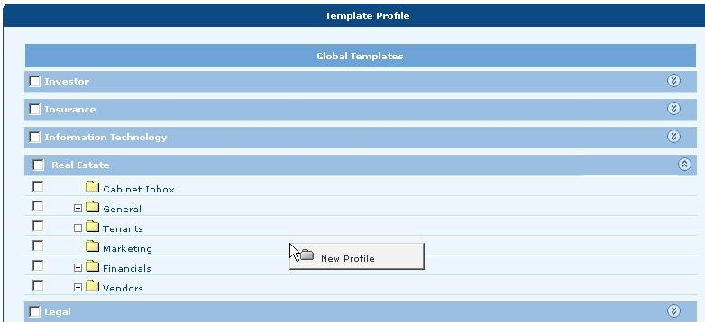

- Follow the same steps as above from To create New Profile.

To Rename Profile
To rename a Profile follow the below steps:
- Select any profile.
- Click Rename Profile button
Result: The Rename screen appears.
An error message pop up box will appear if you do not select any folder or file. Message Reads: “Please select at least one file/folder.”
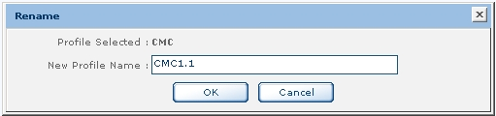
- Rename

- Enter the profile name in the New Profile Name field.
An error message pop up box will appear if you do not enter the profile name. Message Reads: “Please enter name.”
- Click OK button
Message Reads “Are you Sure, Do you want to Rename.”
- Click OK button
Message Reads “ <Folder name> renamed successfully” For Example in the above screen CMC1.1
- Click OK button
Result: The profile is renamed.

To Delete Profile
To delete a Profile follow the below steps:
- Select any profile you wish to delete.
- Click Delete Profile button
Message Reads “Are you Sure, Do you want to Delete?”
- Click OK button
Message Reads “ <Folder name> deleted successfully”
- Click OK button

To create New Folder
To create a new folder follow the below steps:
- Select any folder
An error message pop up box will appear if you do not select any folder or file. Message Reads: “Please select at least one file/folder.”
- Click on New Folder button
Result: Create A New Folder screen appears.
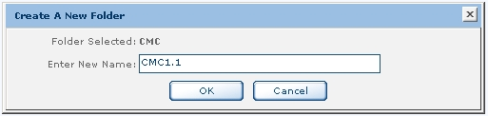
- Create a New Folder

- Enter the new folder name in Enter New Name field.
An error message pop up box will appear if you do not enter the profile name. Message Reads: “Please enter name.”
- Click OK button
Message Reads “Are you Sure, Do you want to create a New Folder? “
- Click OK button
Message Reads “<Folder name> created successfully “ For Example in the below screen it is CMC1.1
- To view the created folder click on Collapse button.
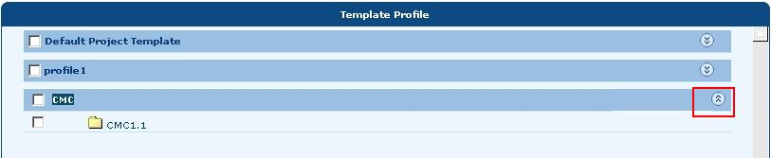

To create New Folder by Shortcut menu
- Right click the global template (CMC in the screen shot is the global template)
Result: A Shortcut menu appears.
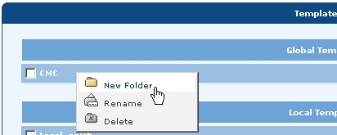
- Select the New Folder option
Result: Create A New Folder screen appears.
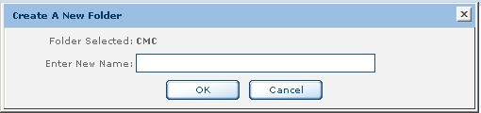
- Create A New Folder

- Enter new folder name in the Enter New Name field.
- Click OK button
A message appears “Are you Sure, Do you want to create new Folder?”
- Click OK button
A message appears “ Folder <Folder name> created successfully”
- Click OK button
- Click on the Expand Profile button to view the folder created
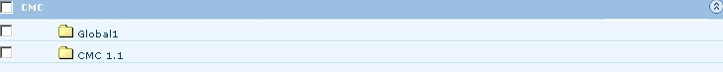
- To collapse the folders click on the Collapse Profile Expand button
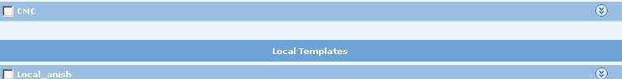

To Rename Folder
To rename a folder follow the below steps:
- Select any folder you wish to rename.
- Click Rename Folder button
Result: The Rename screen appears.
An error message pop up box will appear if you do not select any folder or file. Message Reads: “Please select at least one folder.”
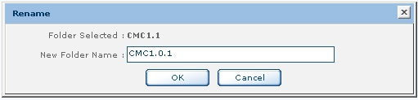
- Rename
- Enter the folder name in the New Folder Name field.
An error message pop up box will appear if you do not enter the new folder name. Message Reads: “Please enter name.”
- Click OK button
Message Reads “Are you Sure, Do you want to Rename.”
- Click OK button
Message Reads “ <Folder name> renamed successfully”
- Click OK button
Result: Will close the message screen.

To Rename Folder by Shortcut menu
To rename a folder or file follow below steps:
- Right click the global template (CMC in the screen shot is the global template)
Result: A Shortcut menu appears.
- Select Rename option
- Result: The Rename screen appears.
- Same as step 2 from above (To Rename Folder).

To Delete Folder
To delete a folder follow the below steps:
- Select any folder
- Click Delete Folder button
Message Reads “Are you Sure, Do you want to Delete?”
- Click OK button
Message Reads “ <Folder name > deleted successfully” For Example in the above screen it is CMC1.0.1
- Click OK button

To Delete Folder by Shortcut menu
To delete a folder follow the below steps:
- Right click the global template (CMC in the screen shot is the global template)
Result: A Shortcut menu appears.
- Select Delete option
- Follow from step 2 as above (To Delete Folder).

- User Profile
The User Profile displays information regarding User, Personal, Regional and Team members. The User Profile menu option has following tabs:
- User Info
- Personal Info
- Regional Info
- Team Members

User Info
The user information is retrieved from HOV Intranet, Administration module.
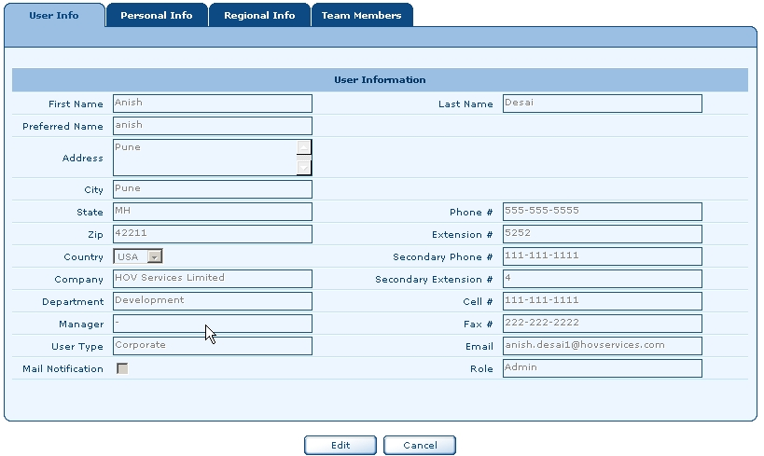
- User Info Tab

To modify the information follow the below steps:
- Click Edit button
Result: The Edit button changes to Update button
- Modify the fields and the user information as you wish
- Click on the Mail Notification check box if you wish the user to send mails.
- Click Update button
Message Reads:
If the Name is blank then an error message appears “First Name should not be [blank] less than 1 characters”
If the Preferred Name is blank then an error message appears “Preferred Name should not be [blank] less than 1 characters”
DocuTracks follows a specific format for the Zip
##### or
#####- ####
If the Last Name is blank then an error message appears “Last Name should not be [blank]less than 1 characters”

If the Phone Number is blank then an error message appears “Enter Phone Number”
Phone Number has a specific format
Contact Phone Number must be in form:
###-###-#### or
(###) ###-#### or
+ ## ### ### #### for international.

ISD Phone Number has a specific format
ISD Phone Number must be in form:
###-###-#### or
(###) ###-#### or
+ ## ### ### #### for international.

Mobile Number has a specific format
Mobile Number must be in form:
###-###-#### or
(###) ###-#### or
+ ## ### ### #### for international.

Fax Number has a specific format
Fax must be in form:
###-###-#### or
(###) ###-#### or
+## ### ### #### for international.

If the Email is blank then an error message appears “ Invalid Email ID”
Button Options Available:
Cancel: Will cancel the changes made to the record.

Personal Info Tab
This tab consists the user login information.
To modify the personal information follow the below steps:
- Click Edit button
Result: 1. Result: The Edit button changes to Update button
2. Change Password field appears.
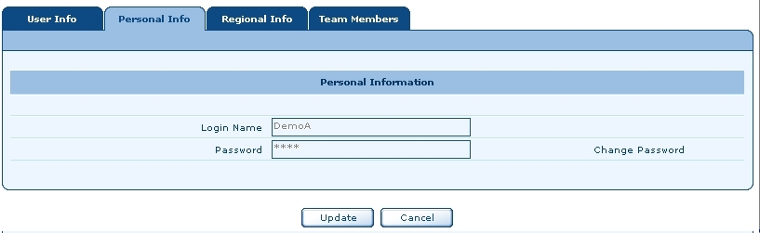
- Personal Info
- Click the Change Password field.
Result: Old Password, New Password, and Confirm Password fields appear.
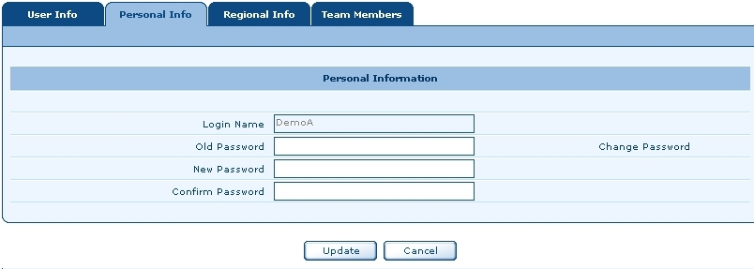

- In the Old Password field enter the old password.
If the Old Password field is blank then an error message appears” Enter old password“
If you have entered wrong old password then a message appears “ Old password not valid”
- In the New Password field enter the new password.
If the New Password field is blank then an error message appears” Enter new password“
New password should not be less than 4 characters.
- In the Confirm Password field enter the new password.
If the Confirm Password field is blank then an error message appears” Enter Confirm password“
- The New Password and Confirm Password must match each other else an error message appears “ The New Password and Confirm Password must be same.”
- Click Update button
Button Option Available:
Cancel: Will discard the changes made to the fields.

Regional Info Tab
The Regional Info Tab provides information on Date Format, Default Currency, and Time Zone.
To edit the details on the Regional Information Tab follow the below steps:
- Click Edit button
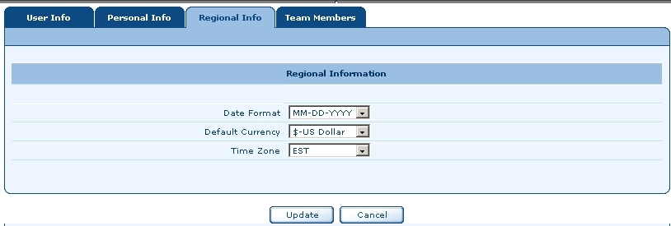

- Regional Info
- Click on the Date Format if you wish to edit. This field has following formats:
DD-MM-YYYY
MM-DD-YYYY
YYYY-MM-DD
- Click on the Default Currency if you wish to edit. This field has following formats:
$- US Dollar
# - Pounds
- Click on the Time Zone if you wish to edit. This field has following formats:
  - EST
  - PST
  - CST
  - IST
Button Option Available:
Cancel: Will discard the changes made to the fields.

Team Members Tab
You cannot edit or update any information from this tab. You can only view the team member names in this tab.
- Permission
The Permission Tab allows you to set permissions on folders or files. There are different permissions for Root Folder permissions, Project permissions and Files permissions.

Root Folder Permissions
The Root folder has two permissions:
- Disable All
- New Folder
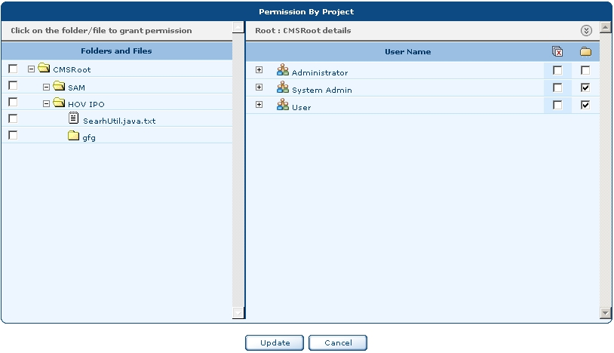
- Root Folder Permissions
The root folder has only two permissions:
Permissions | Description
 | This icon indicates Disable folder. If this folder is selected then all the folders appear disabled for that particular project.
 | This icon indicates New Folder. If this folder is selected then you can create new folders for the selected project.

Project Permissions
Project Permissions has eight permissions:
- Disable All
- Permit All
- Read Only
- New Folder
- Rename
- Delete
- Upload
- Download
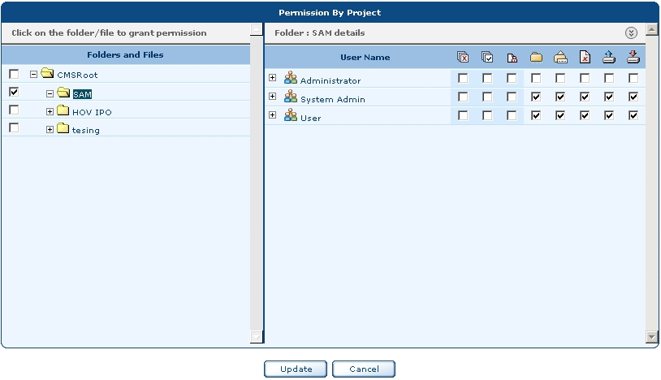
- Folder Permissions
Permissions | Description
 | This icon indicates Disable folder permission. If this folder is selected then all the folders appear disabled for that particular project.
 | This icon indicates Permit All permission. Permit All works as Select All. If you select this option then all the folders are checked except Read Only permission.
Permissions | Description
 | This icon indicates Read Only permission. If you select this option then permissions like creating New Folder, Rename folders, Deleting folders, and Uploading folders are restricted.
 | This icon indicates New Folder permission. If this option is selected then you can create new folder.
 | This icon indicates Rename permission. If this option is selected then you can rename folder.
 | This icon indicates Delete permission. If this option is selected then you can delete folder.
 | This icon indicates Upload permission. If this option is selected then you can upload the folders or files.
 | This icon indicates Download permission. If this option is selected then you can download the files.

Files permissions
File Permissions has seven permissions:
- Disable All
- Permit All
- Read Only
- Rename
- Modify File
- Delete
- Download
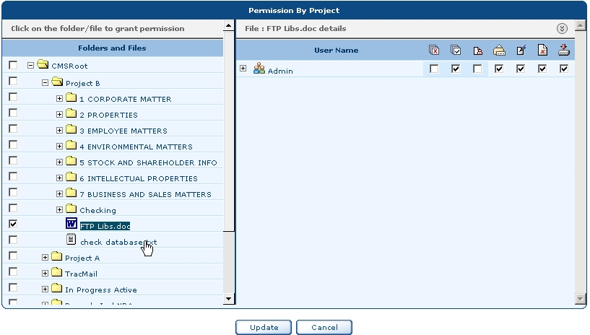
- File Permissions
Permissions | Description
 | This icon indicates Disable folder. If this folder is selected then all the folders appear disabled for that particular project.
 | This icon indicates Permit All permission. Permit All works as Select All. If you select this option then all the folders are checked except Read Only permission.
 | This icon indicates Read Only permission. If you select this option then permissions like creating New Folder, Rename folders, Deleting folders, and Uploading folders are restricted.
 | This icon indicates Rename permission. If this option is selected then you can rename folder.
 | This icon indicates Modify File permission. If this option is selected then the users will have permission to modify files.
 | This icon indicates Delete permission. If this option is selected then you can delete folder.
 | This icon indicates Download permission. If this option is selected then you can download the files.

Permission can be granted by three methods:
- By Project
- By User
- By Template

By Project
To grant a permission by Project follow the below steps:
- Click on the Permission Tab
Result: The Permission Tab appears.
- From the Grant Permission By select either Project or User
- Select Project
Result: From the left side all the folders appear.
- Select the folder.
Result: The Username appear on the right side.
You can include permissions for sub folders as follows:
- From the Permission select the By Project
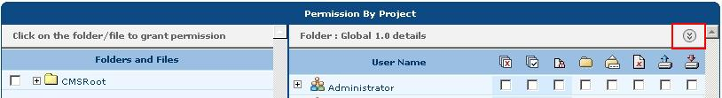

- Select any folder
Result: The Folder Permissions appear.
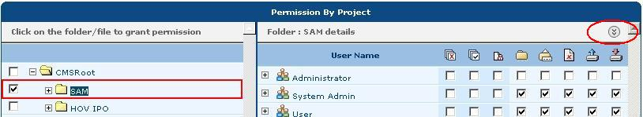

- Click the Expand button
Result: The Folder details appear.
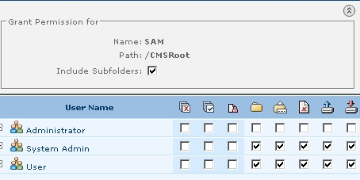
- Click the Include Subfolders to grant the same permissions for the subfolders.
- To hide the folders details click Collapse button
Result: The Folder details screen is closed.

By User
To grant a permission by User follow the below steps:
- Select the Permission option from the Vertical Bar
Result: The Permission Tab appears.
- From the Grant Permission By select User
Result: From the left side all the Username appear and on the right side folders and files
appear.

To Update the user permissions follow below steps:
- In the Permission Tab select the permission you wish to give.
- Click Update button
Button Options Available:
Cancel: Will close the Permission screen and the Project View Tab appears.

By Template
To grant a permission by Template follow the below steps:
- From the Vertical Bar click on the Permission
Result: The Permission menu options appear.
- Select By Template option.
Result: Permission By Template screen appears.
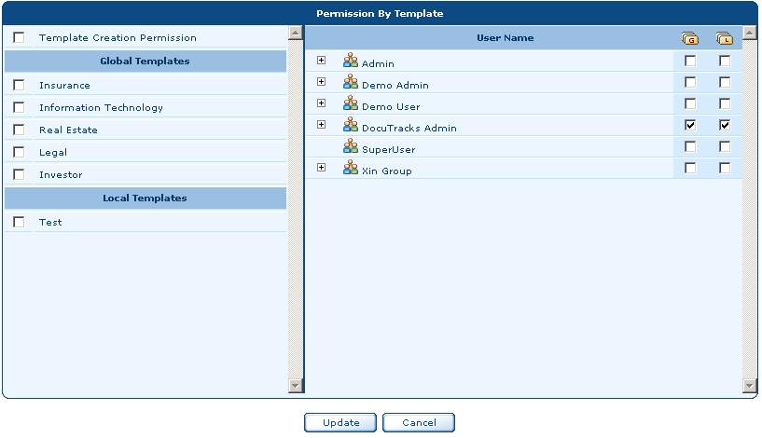
- Permission By Template
To grant a Template Creation permission follow the below steps:
- Click Template Creation Permission check box at the top left corner of the screen
Result: The User Names appear with Global Template and Local Template permission.
- The Template Creation Permission check box is divided in
  - Global Templates and
  - Local Templates
Permissions | Description
 | This icon indicates Global Template. If this is selected then all the templates are accessible to all the users.
 | This icon indicates Local Template. If this is selected then all the templates are accessible only to local users.

You can either select Global Template or Local Template or both the templates to grant permission.
- To grant Global Template permission to the User; click the check box below Global Template. Similarly to grant Local Template permission to the User; click the check box below Local Template.
- If you wish to give permission to the group then just select the group For Example Admin. By default all the users having Administration rights will have the Global Template permission.
- Click Update button
To grant permission to Global Templates follow the below steps:
- Under the Global Templates heading you will find list of Global Templates.
- Select any Template to grant permission.
Following are the permissions available for the Global Template
Permissions | Description
 | This icon indicates Disable folder. If this folder is selected then all the folders appear disabled for that particular project.
 | This icon indicates Permit All permission. Permit All works as Select All. If you select this option then all the folders are checked except Read Only permission.
 | This icon indicates Read Only permission. If you select this option then permissions like creating New Folder, Rename folders, Deleting folders, and Uploading folders are restricted.
 | This icon indicates New Folder permission. If this option is selected then you can create new folder.
 | This icon indicates Rename permission. If this option is selected then you can rename folder.
 | This icon indicates Delete permission. If this option is selected then you can delete folder.

To grant permission to Local Template follow the below steps:
- Under the Local Templates heading you will find list of Local Templates.
- Select any Template to grant permission.
Please refer to Global Template permissions from step 3.

- Administration
The Administration menu displays information regarding Users and Group. The Administration menu has following option:
- Users
- Groups

Users
The Administrator can create Users and Groups. The description of the Users and Groups is as follows:
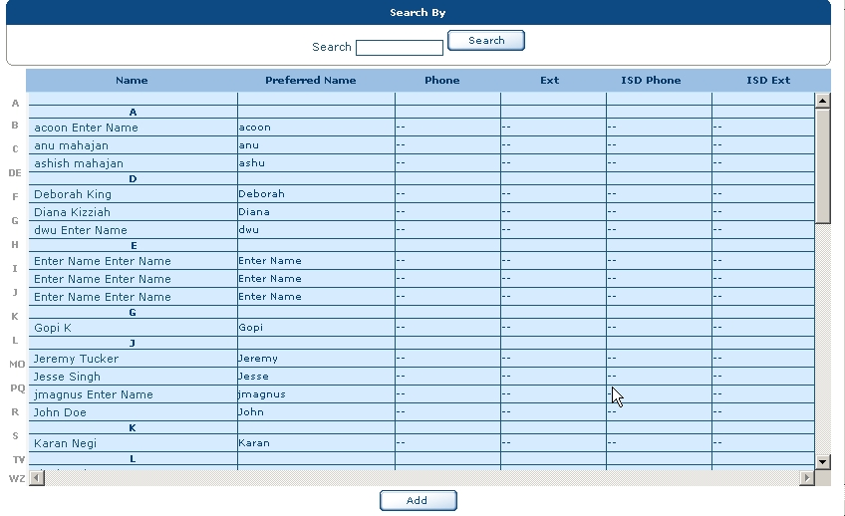
- User

The User screen displays the names of the users in alphabetical order. To view the information you can click on any User name. Similarly the screen allows you to Search and Add the Users. For more information on Searching the Users please refer to Search topic.

User Info Tab
To create an User follow the below steps:
- Click on the Administration menu
Result: The two menu options appear namely
  - Users
  - Groups
- Click Users menu option
Result: The Users screen appears.
- Click Add to create a new User
Result: The User Info Tab appears
- Enter the information in the User Info Tab.
Fields marked in the * sign are mandatory fields.
- Click Save button
Result: The User is added in the Users screen.
Button Options:
Cancel: Will close the User Info Tab screen without saving the information.

Login Info Tab
To create an User login follow the below steps:
- Click on the Administration menu
Result: The two menu options appear namely
  - Users
  - Groups
- Click Users menu option
Result: The Users screen appears.
- Click Add to create a new User
Result: The User Info Tab appears
- Click Login Info Tab
Result: The Login Information screen appears.
- Enter the information in the Login Info Tab.
Fields marked in the * sign are mandatory fields.
- Click Save button
Button Options:
Cancel: Will close the User Info Tab screen without saving the information.

Regional Info Tab
To add an Regional information follow the below steps:
- Click on the Administration menu
Result: The two menu options appear namely
  - Users
  - Groups
- Click Users menu option
Result: The Users screen appears.
- Click Add to create a new User
Result: The User Info Tab appears
- Click Regional Info Tab
Result: The Regional Information screen appears.
- Enter the information in the Regional Info Tab.
- Click Save button
Button Options:
Cancel: Will close the User Info Tab screen without saving the information.

Groups
The Group screen displays the names of the user groups. To view the information you can click on any Group Name. Similarly the screen allows you to Search and Add the User Groups.
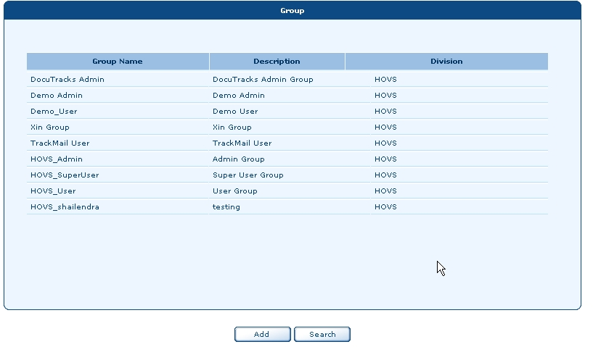

To create a Group follows below step:
- Click on the Administration menu
Result: The two menu options appear namely
  - Users
  - Groups
- Click Groups menu option
Result: The Groups screen appears.
- Click Add to create a new User
Result: The Group screen appears
- Enter the information in the Group screen.
- Click Save button
- Result: The Group is added in the Group screen.
Button Options:
Cancel: Will close the User Info Tab screen without saving the information.

To Search a Group follows below step:
- Click on the Administration menu
Result: The two menu options appear namely
  - Users
  - Groups
- Click Groups menu option
Result: The Groups screen appears.
- Click Search to search a Group
Result: The text field and Go button appears
- Enter the Group name in the text field
- Click on Go or press Enter key.
If the search criteria is not found then a message appears “ No record found ”
Result: The search criteria’s appear in the Group screen.
- Click on the Group Name
Result: The Group information appears.

You can Edit a Group follows below step:
- Click on Edit button
- Modify the fields you wish.
- Click Save button
Result: Group modified successfully
You can Delete a Group follows below step:
- Click on Delete button
- Result: Are you sure to Delete a record?
- Click OK button
Result: Record deleted successfully.

Search
Search has following options:
- Business Unit
- Division
- Search By

These options depend on User Type and Role fields in the User Info Tab. The explanation is given below.
The User Type field has following options:
- Corporate
- Business Unit
- Division
- Department
The Role field has following options:
- Admin
- Super user
- User

Corporate Option:
If the Administrator selects Corporate Option and Role as Admin then Search options like Business Unit, Division and Search By Name are available.

Business Unit:
If the Administrator selects Business Unit and Role as Admin then Search options like Division and Search By Name are available.

Division
If the Administrator selects Division and Role as Admin then Search option like Search By Name is available.

Department
If the Administrator selects Department and Role as Admin then Search options like Corporate, Business Unit, Division and Search By Name are available.

- Reports
There are five types of reports
- Upload File
- User Logs
- Deleted Files
- User Audit
- Retention Files

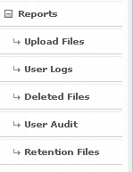

Uploaded Files
Uploaded Files enabled you to view the files that are uploaded between specific dates.
To view the uploaded files follow below steps:
If you have permission for one project then you will not see the Project option. You will view the screen as follows:

- Click on the Report menu
Result: The report sub options are displayed
  - Upload Files
  - User Logs
  - Deleted Files
  - User Audit

- Click on Upload Files option
Result: Upload File screen appears.

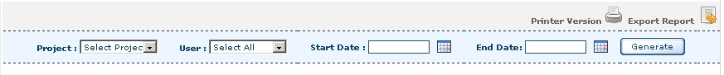
- Click on the arrow and select the Project name from the available list.
- Click on the arrow and select the User name from the available list. You can either select any user or Select ALL, which is selected by default.
- Click on the calendar icon and select the Start date.
- Move the cursor to the Start Date field.
Result: A tool tip appears “Enter Date in DD-MM-YYYY format”
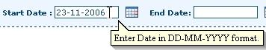
- Click on calendar icon and select the End date
- Move the cursor to the End Date field.
Result: A tool tip appears “Enter Date in DD-MM-YYYY format”
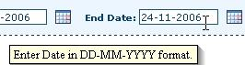
- Click Generate button
Result: A User file upload report appears.
An error message pop up box will appear if the Start Date and End Date field is not populated on the Login Screen. Message Reads: “Enter the date”
For more details refer to Print Report.
For more details refer to Export Report.

User Logs
To view the User Logs follow below steps:
- Click on User Logs option
Result: User Logs screen appears.
- From the Project select the particular Project. By default, Select All option is selected.
- From User select the particular user. By default, Select All option is selected.
- Click on the calendar icon and select the Start date.
- Move the cursor to the Start Date field.
Result: A tool tip appears “Enter Date in DD-MM-YYYY format”
- Click on calendar icon and select the End date
- Move the cursor to the End Date field.
Result: A tool tip appears “Enter Date in DD-MM-YYYY format”
- Click Generate button
Result: User Login / Logout report is generated.
For more details refer to Print Report.
For more details refer to Export Report.

Deleted Files
To view the deleted files follow below steps:
- Click on Deleted Files
Result: Deleted Files screen appears.
- From the Project select the particular Project. By default, Select All option is selected.
- From User select the particular user. By default, Select All option is selected.
- Click on the calendar icon and select the Start date.
- Move the cursor to the Start Date field.
Result: A tool tip appears “Enter Date in DD-MM-YYYY format”
- Click on calendar icon and select the End date
- Move the cursor to the End Date field.
Result: A tool tip appears “Enter Date in DD-MM-YYYY format”
- Click Generate button
Result: Deleted Files report is generated.

For more details refer to Print Report.
For more details refer to Export Report.

User Audit
To view the User Audit follow the below steps:
- Click on User Audit
Result: User Audit screen appears.
- From the Project select the particular Project. By default, Select All option is selected.
- From User select the particular user. By default, Select All option is selected.
- Click on the calendar icon and select the Start date.
- Move the cursor to the Start Date field.
Result: A tool tip appears “Enter Date in DD-MM-YYYY format”
- Click on calendar icon and select the End date
- Move the cursor to the End Date field.
Result: A tool tip appears “Enter Date in DD-MM-YYYY format”
- Click Generate button
Result: Deleted Files report is generated.

For more details refer to Print Report.
For more details refer to Export Report.

Retention Files
To view the retention files follow below steps:
- Click on Retention Files
Result: Retention Files screen appears.
- From the Project select the particular Project. By default, Select All option is selected.
- Click on the calendar icon and select the Start date.
- Move the cursor to the Start Date field.
Result: A tool tip appears “Enter Date in DD-MM-YYYY format”
- Click on calendar icon and select the End date
- Move the cursor to the End Date field.
Result: A tool tip appears “Enter Date in DD-MM-YYYY format”
- Click Generate button
Result: Retention Files report is generated.
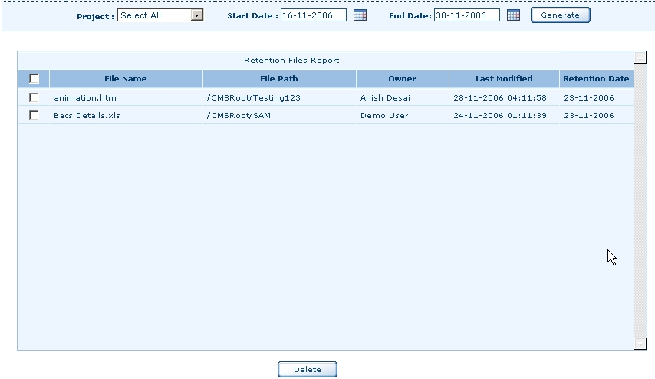
- Retention Files Report

To delete the file follow the below steps:
- Select the particular file
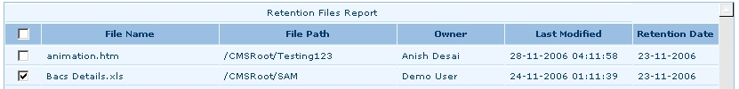
- Click Delete button
Result: A message appears “<filename> deleted”
For more details refer to Print Report.
For more details refer to Export Report.

Print Report
To take a print of the report follow the below steps:
- Keep the cursor on the Printer Version
Result: A tool tip appears “Click here to get Print Preview of the report”.
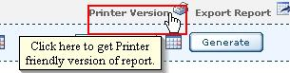

- Click on the Printer Version
Result: A print preview Page appears.
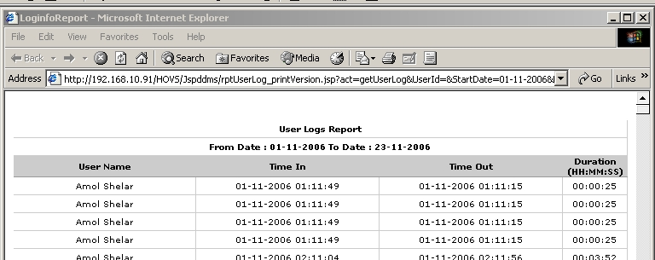

- From the File menu select Print option.
An error message will appear the Start Date and End Date field is not populated on the Login Screen. Message Reads: “Enter the date”

Export Report
To export the report follow the below steps:
- Keep the cursor on the Export Report
Result: A tool tip appears “Click here to get Print Preview of the report”.

- Click on the Export Report
Result: Export Report screen appears.
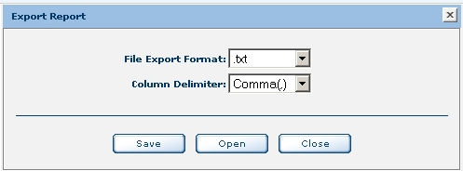
- From the File Export Format select the type of format
- .txt
- .xls
File Type | Description
.txt | Opens the report in the text (notepad)
.xls | Opens the report in the excel sheet
From the Column Delimiter select the delimiter
- Comma (,)
- Semicolon (;)
- Tab data
The Column Delimiter options are available only for .txt file format.
Button Options Available:
Save: Will save the report at the specified location.
Open: Will open the report in the selected file format
Close: Will Close the report.

